**Activity Diagram for Online Gas Ordering System**

1. Activity for Login

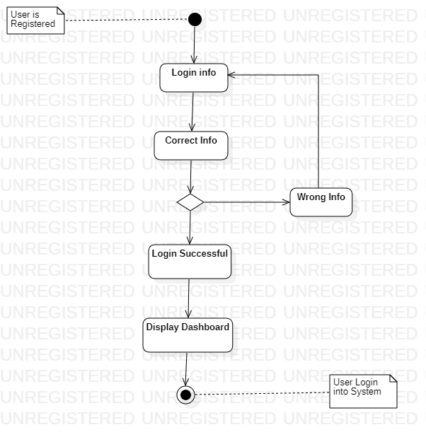

* Description

When a user registered in the system he needs to then login into the system in order to access the system in full.

The user has to provide his login information, the sstem will check if the information are correct or not. If the information is correct, a success message will be displayed and the user (customer, admin …) dashboard will open. If the login information is wrong an error message will display and the system will prompt the user to login again.

1. Activity for Order

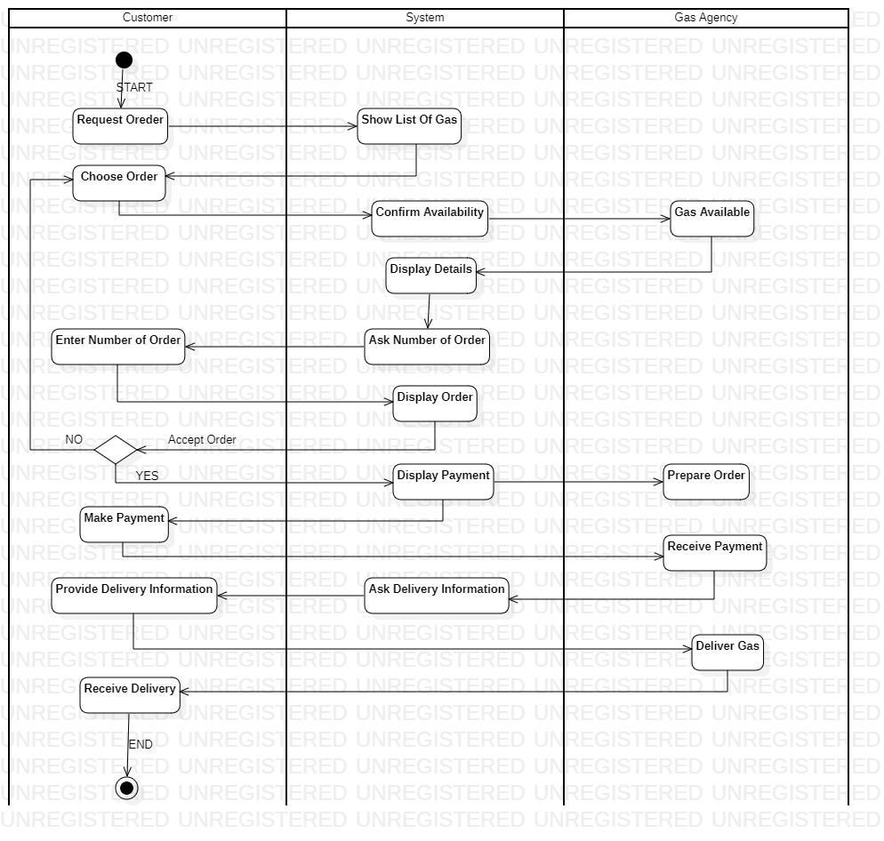

* Description

There are three (3) swimlanes (partitions) here: The Customer, the System and the gas agency.

When a customer reguest for an order the system will show a list of gas, the customer will then choose an order. The system will check the availability of the chosen order by contacting the gas agency. If order is available the system will display details of the order and ask the customer to enter number of orders when that is done, the order will display and now left for the customer to accept or reject order. If the customer accept it then system will display payment for yhe customer to make.